

Mathematics Department |  | 
Course: A2MAA
Topic Title: Test 3 Calculator Free
Student Name:_____________________________________ | Date: ____________
Special Instructions: Formula Sheet allowed and no calculators | Time Allowed: 10 minutes
Show all working clearly | Marks: / 10

Question 1. (4 marks)

Use the triangle below to obtain the fractions for the trigonometric ratios given.

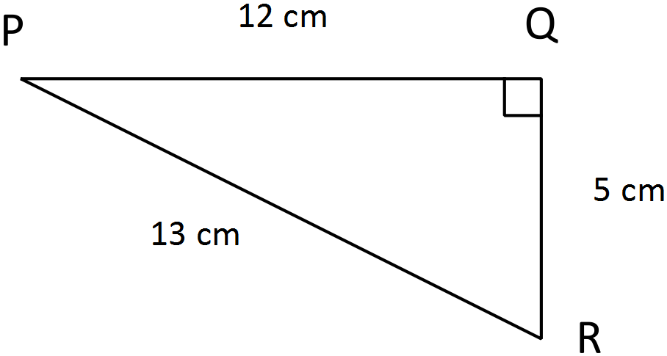
- sin P = $\frac{5}{13}$

- sin R = $\frac{12}{13}$

- cos R = $\frac{5}{13}$

- tan P = $\frac{5}{12}$

Question 2. (2 marks)

If $sin30=0.5$ , calculate the length of the missing side.

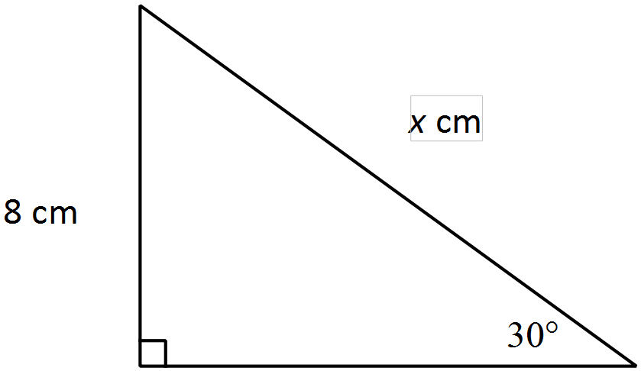 $sin30°=\frac{8}{x}$

$x=\frac{8}{0.5}$

$x=16cm$

Question 3. (2 marks)

Calculate the bearing of A from B in the following two scenarios.

- 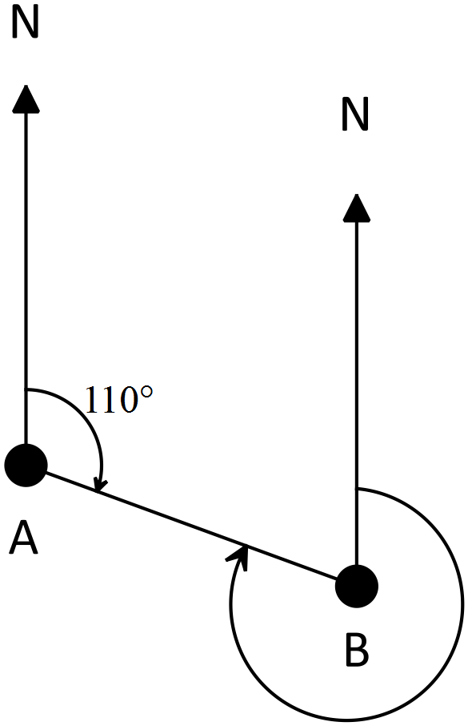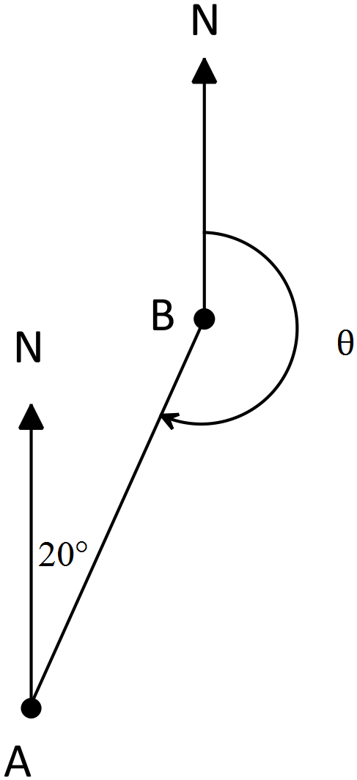b)

Bearing of A from B is 200° Bearing of A from B is 290°

Question 4. (2 marks)

If $sin30=0.5$, calculate the area of the triangle below.

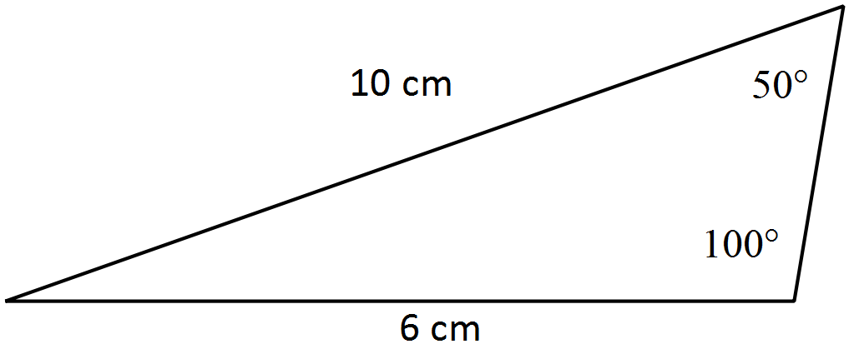

Area = $0.5×a×b×sinC$
$=0.5×10×6×sin30°$
= $0.5×10×6×0.5$
= 15cm²

